

ROS2 Driver Manual (Ubuntu in WSL)
For I-79 48 4D Imaging Radar

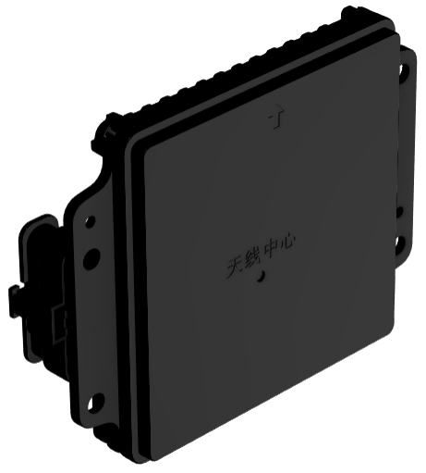

Revision History
Release Version | Date | Authors | Approved By | Notes
1.0 | 1/7/2026 | Michael Dahn |  | Initial Release
1.1 | 1/16/2026 | Michael Dahn |  | Updated Procedures

Table of Contents

Table of Contents 1
Installing ROS2 Jazzy and Dependency Installation 2
WSL and Ubuntu 24.04 Installation 2
ROS2 Jazzy Jalisco Installation 4
Package Dependencies Installation 5
ROS2 Driver Installation 7
Hardware Passthrough to WSL 8
Passing from Windows to WSL 8
Configuring USB device in WSL 9
Using the ROS2 Driver 12

Installing ROS2 Jazzy and Dependency Installation

This section will cover the steps to setup the ROS2 Jazzy Jalisco for Ubuntu 24.04 for Noble Numbat for Windows Subsystem for Linux (WSL). The installation of ROS2 and the necessary dependencies will then be covered.

WSL and Ubuntu 24.04 Installation
- Open a Command Prompt Window with administrator privileges and enter
>> wsl --version to determine if WSL is already installed on the system.
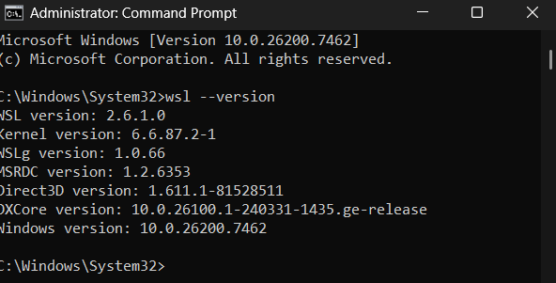
Figure 1 - WSL Version in Command Prompt
If an error occurs, run >> wsl --install to install WSL onto your system.

- Following the verification of WSL on the system, proceed to the Microsoft Store and search for “Ubuntu 24.04” and install the current version.
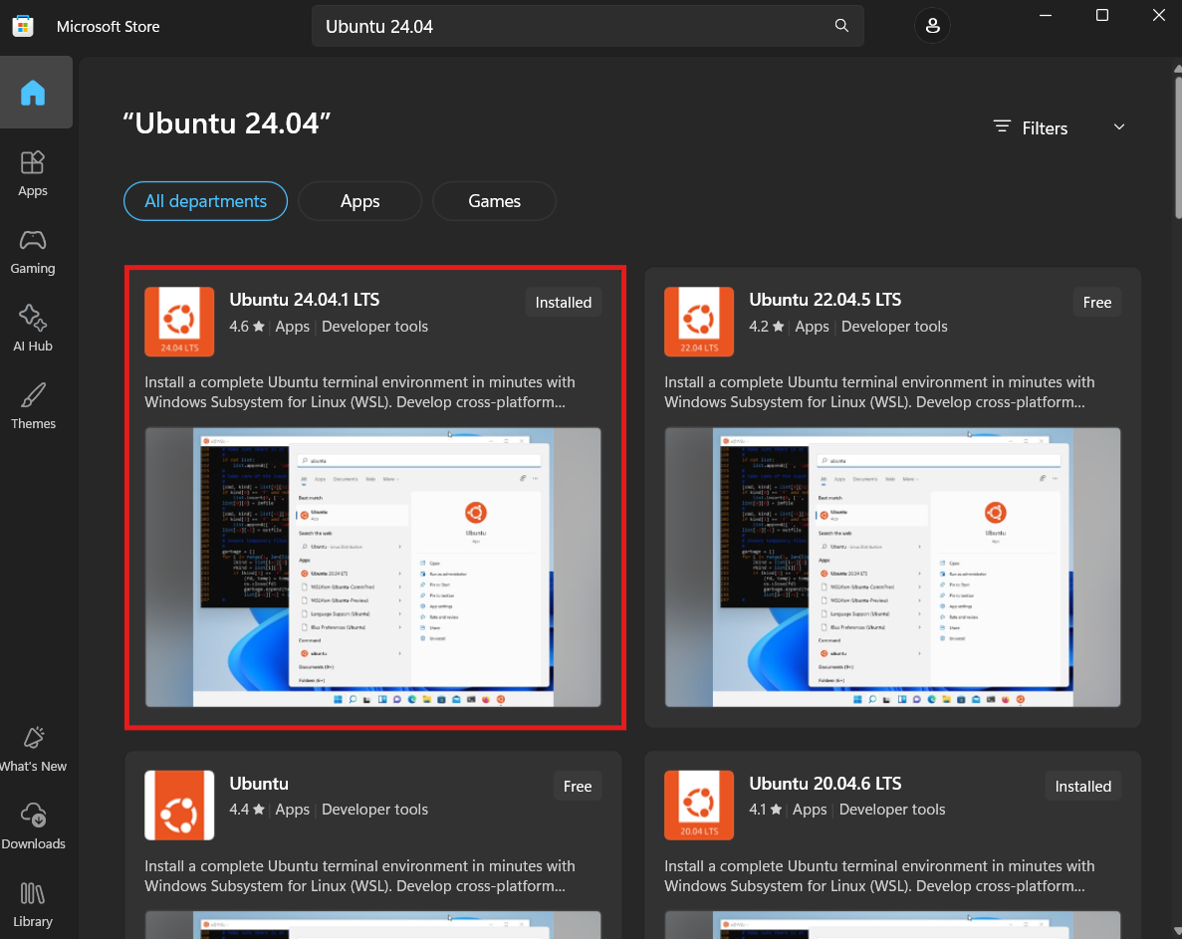
Figure 2 - Installing Ubuntu 24.04.x from Microsoft Store
- After installing Ubuntu 24.04.x, press the Windows Key and then Search for Ubuntu 24.04.x and select open.
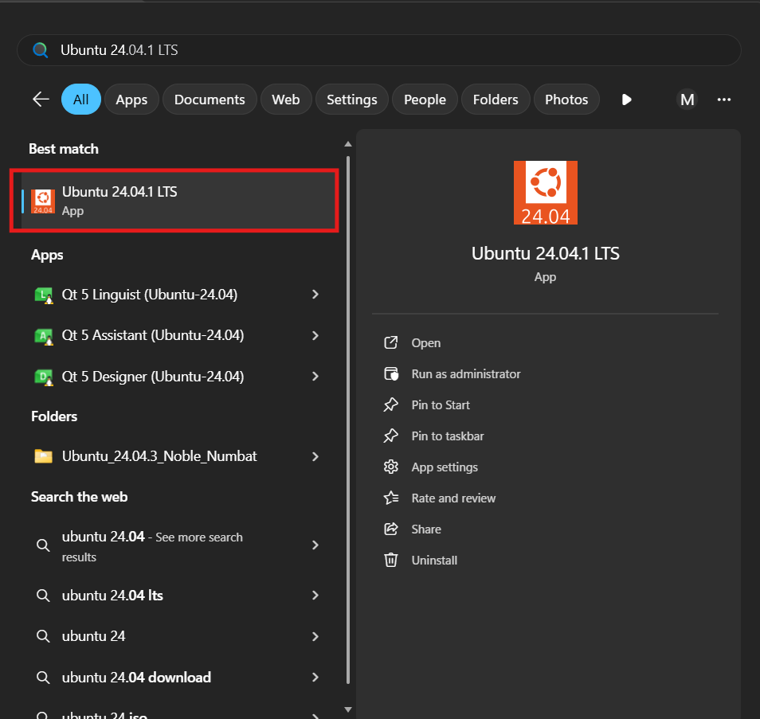
Figure 3 - Running Ubuntu 24.04
- This will open a new bash terminal for Ubuntu 24.04.x which indicates the successful installation of WSL and Ubuntu 24.04
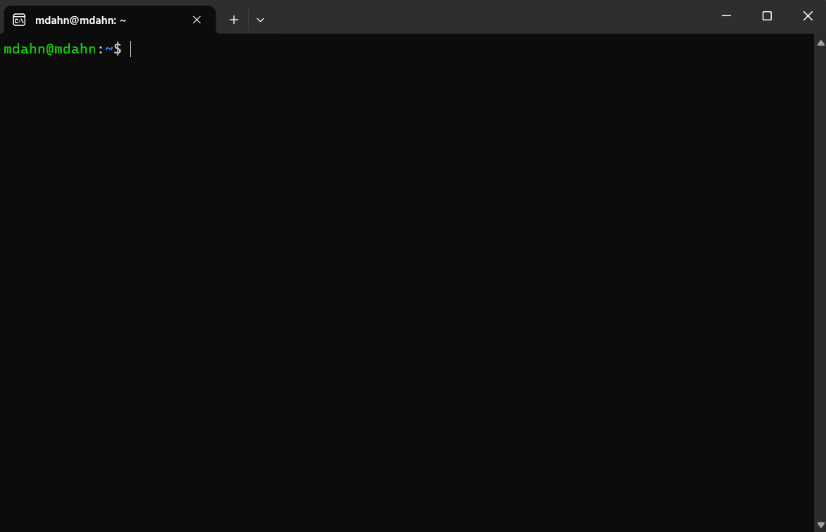
Figure 4 - Bash terminal for Ubuntu 24.04

ROS2 Jazzy Jalisco Installation
This section will detail the installation of ROS2 Jazzy Jalisco as a binary package per the ROS documentation [link]. Run the following commands in the bash terminal for Ubuntu 24.04 as described above.

Set locale
>> locale
>> sudo apt update && sudo apt install locales
>> sudo locale-gen en_US en_US.UTF-8
>> sudo update-locale LC_ALL=en_US.UTF-8 LANG=en_US.UTF-8
>> export LANG=en_US.UTF-8
>> locale

Enable Required Repositories
>> sudo apt install software-properties-common
>> sudo add-apt-repository universe
>> sudo apt update && sudo apt install curl -y
>> export ROS_APT_SOURCE_VERSION=$(curl -s https://api.github.com/repos/ros-infrastructure/ros-apt-source/releases/latest | grep -F "tag_name" | awk -F\" '{print $4}')
>> curl -L -o /tmp/ros2-apt-source.deb "https://github.com/ros-infrastructure/ros-apt-source/releases/download/${ROS_APT_SOURCE_VERSION}/ros2-apt-source_${ROS_APT_SOURCE_VERSION}.$(. /etc/os-release && echo ${UBUNTU_CODENAME:-${VERSION_CODENAME}})_all.deb"
>> sudo dpkg -i /tmp/ros2-apt-source.deb

Install Development Tools
>> sudo apt update && sudo apt install ros-dev-tools

Install ROS2
>> sudo apt update
>> sudo apt upgrade
>> sudo apt install ros-jazzy-desktop
>> sudo apt install ros-jazzy-ros-base
>> source /opt/ros/jazzy/setup.bash

Note: there are available examples on the installation page accessible through the link above.

Package Dependencies Installation
- DBC Parser Installation
Run the following commands within the bash terminal from Ubuntu 24.04
>> cd ~
>> git clone https://github.com/xR3b0rn/dbcppp.git
>> cd dbccppp
>> mkdir build && cd build
>> cd ~/dbcppp
>> git submodule update --init --recursive
>> cd build
>> cmake -DCMAKE_BUILD_TYPE=Release ..
>> make
>> sudo make install
>> sudo ldconfig
>> ldconfig -p | grep libdbcppp

- vSomeIP Installation
Run the following commands within the bash terminal from Ubuntu 24.04
>> sudo apt update
>> sudo apt install libboost-all-dev cmake build-essential git -y
>>cd ~
>>git clone https://github.com/COVESA/vsomeip.git
>> cd vsomeip
>> mkdir build && cd build
>> cmake -DENABLE_SIGNAL_HANDLING_OFF=1 ..
>> make
>> sudo make install
>> sudo ldconfig
>> ldconfig -p | grep libvsomeip

Note: that the cmake command may throw several warnings, but you may proceed to the make command. If the installation is successful then libvsomeip3.so.3 should be present in the output of the last command.

- libpcanbasic Installation
Run the following commands within the bash terminal from Ubuntu 24.04
>> cd ~
>> wget https://www.peak-system.com/quick/BasicLinux -O BasicLinux.tar.gz tar -xzf BasicLinux.tar.gz
>> wget https://www.peak-system.com/quick/linux -O driver.tar.gz
>> tar -xzf driver.tar.gz
>> cd ~/PCAN-Basic_Linux-*/libpcanbasic
>> make **This line is likely to throw an error, proceed to (A) if no error exists
>> cd ~/peak-linux-driver-*/driver
>> sudo cp pcan.h pcanfd.h /usr/include
>> cd ~/PCAN-Basic-Linux-*/libpcanbasic
>> make
(A) >> sudo make install
>> sudo ldconfig
>> ldconfig -p | grep libpcanbasic

Note that if libpcanbasic.so is present within the output of the last command, the pcan basic installation was successful.

ROS2 Driver Installation
This section covers the installation of the ROS2 driver package from Muniu. You can change the “ros2_ws” to whatever name you like. Additionally the relevant packages are detailed.

1. Setup up workspace and copy driver
After downloading the ROS2 package onto the Windows system into the downloads folder proceed with the following commands for installing the ROS2 driver package for I-79 48 4D Imaging Radar.

>> mkdir -p ~/ros2_ws/src
>> cd ~/ros2_ws/src
>> cp /mnt/c/Users/<Username>/Downloads/radar_ros2_pkg.tar.bz2
>> tar -xvf radar_ros2_pkg.tar.bz2
>> source install/setup.bash

2. Verify driver packages
>> ros2 pkg list
If the following topics are present the installation was successful.
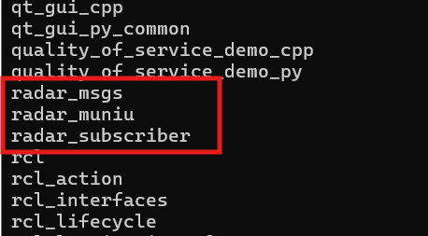
Figure 5 - ROS2 Packages

Hardware Passthrough to WSL

By default, WSL does not have access to the Windows managed USB devices so you will have to pass the ethernet to usb adapter to WSL.

Passing from Windows to WSL
- Open command prompt with administrator privileges
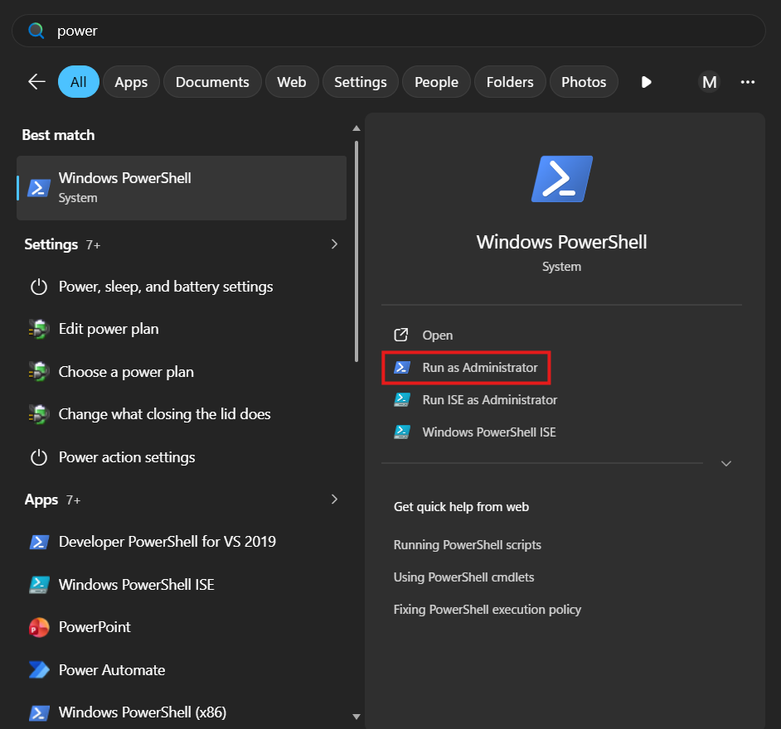
Figure 6 - Windows powershell with administrator privileges
- Run the following command the first time to install usbipd
>> winget install --interactive --exact dorssel.usbipd-win

- Then run the following command to list the available usb devices
>> usbipd list
Find the ethernet adapter in the listed devices and note the BUSID
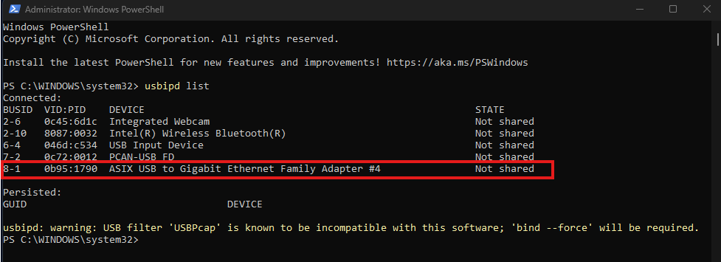
Figure 7 - USB devices from USBIPD

- Bind the device to usbipd
>> usbipd bind --busid <BUSID> --force (e.g. usbipd bind --busid 8-1 --force)
- Finally, attach the device to WSL using
>> usbipd attach –wsl –busid <BUSID>
Note that a WSL distribution must be running (ensure that an Ubuntu 24.04 console is open per “WSL and Ubuntu 24.04 Installation” steps 3 and 4). If there is not a WSL distribution running you will see this message
Figure 8 - Error requiring WSL Distribution to be run
If successful you will see the following message
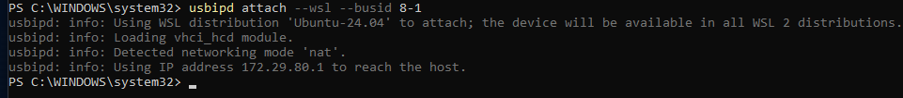
Figure 9 - Properly attached usb device to WSL

Configuring USB device in WSL
- Now in the WSL console run the following to verify the device is now available to WSL
>> lsusb
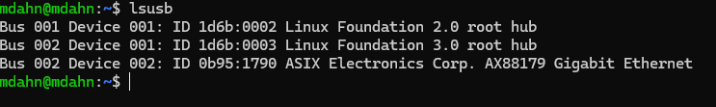
Figure 10 - Listing usb devices available in WSL
- Then check that it is also available on the network level in WSL by running the following
>> ip link
Find your device in the list and note the device id (“enxc8a362d33e69”)
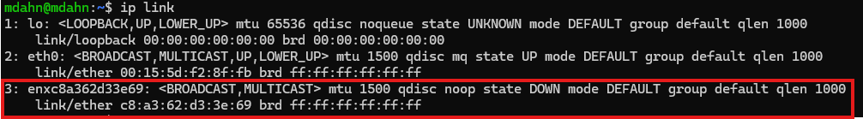
Figure 11 - Finding device id of ethernet adapter in WSL

- Turn the interface up, then use tcpdump to look for necessary IP address
>> sudo ip link set <device id> up
>> sudo tcpdump -i <device id> -n -v
Look for a line similar to the following in the output
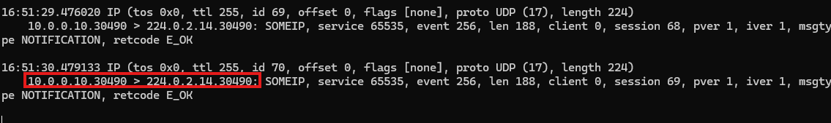
Figure 12 - Determining network parameters
Where,
10.0.0.10 is the source IP, .3049 is the source port, 224.0.2.14 is the destination IP, and .30490 is the destination port
- Route the radar traffic to the ethernet adapter by
>> sudo ip route add 244.0.0.0/4 dev <device id>
- Enter VS Code by running
>> code .
The following files will need changed to reflect the device id as well as the relevant network parameters.
install/radar_muniu/share/radar_muniu/config/radar_muniu_config.yaml

In this file, the local port may need to be changed depending on the results of the tcpdump
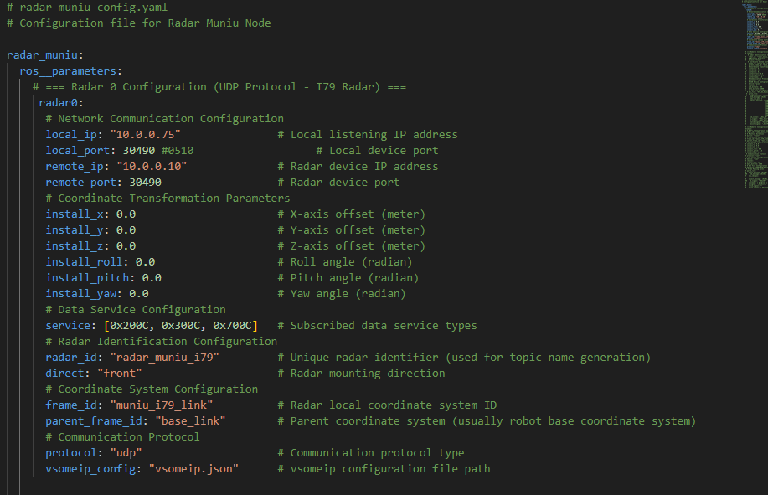
Figure 13 - Changing the .yaml config file

install/radar_muniu/share/radar_muniu/config/vsomeip.json
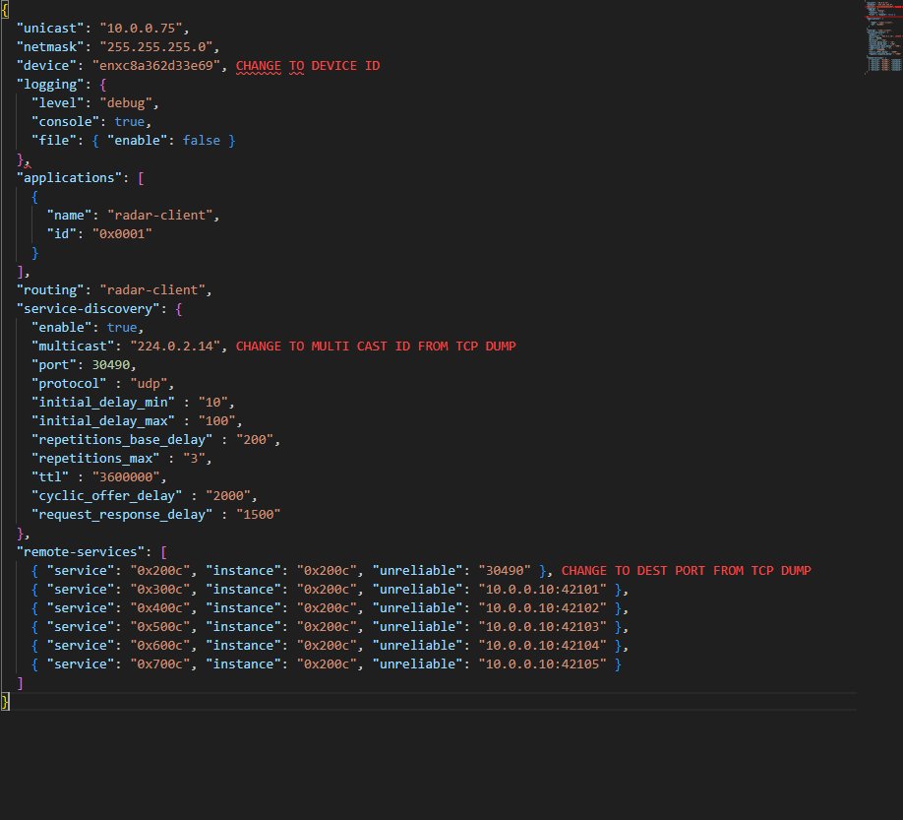
Figure 14 - Changing the .json config file

Using the ROS2 Driver

This section details running the ros2 node once all above steps are completed.
- Begin my setting the current directory to the src directory where the package was installed.
>> cd ~/ros2_ws/src

- Now source the terminal to ros if not already completed
>> source /opt/ros/jazzy/setup.bash

- Source the setup file within the package
>> source install/setup.bash

- Call the publisher node
>> ./publish.sh

- Running this script should make the RVIZ window appear. Ensure that the Fixed Frame field and the Reference Frame fields within the RVIZ window are both set to muniu_i79_link, and that the point cloud2 checkbox for /radar_muniu_i79/vis/detection_list is the only point cloud enabled.
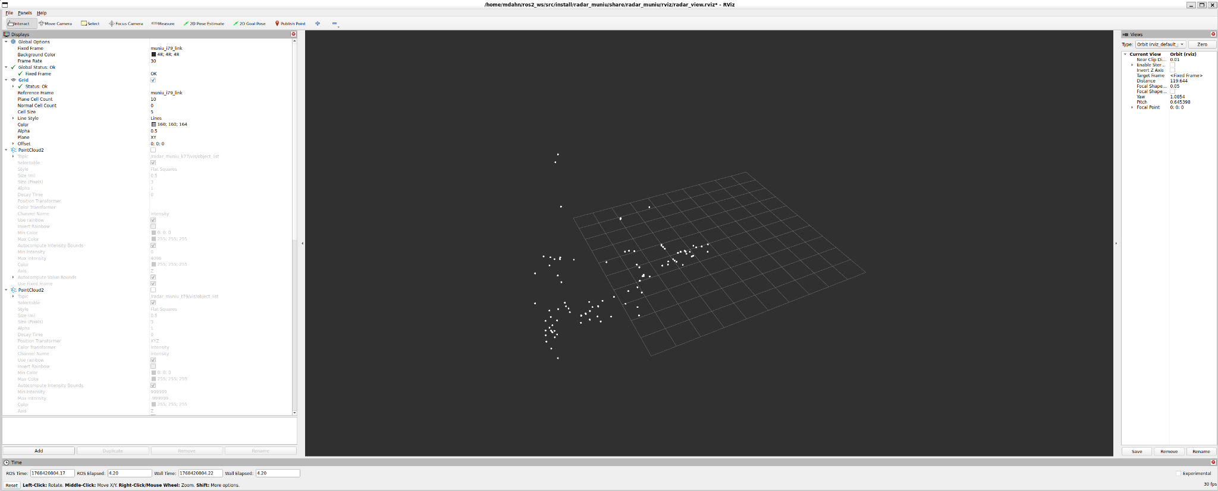

- If there is no radar data present in the RVIZ window. In another terminal window for Ubuntu, and repeat steps 1-3 within the new terminal.
>> ros2 topic echo /radar_muniu_i79/data/detection_list

If there is still no output from this topic, this indicates that the radar is not properly connected to the ros2 node. Check the configuration files to correct the device id and network settings.

